## Marine SCW event

### Questions

* What type of event is this marine event? Is it different to the events in Brown et al. 2023?
* At what height did the air within the surface gust front originate?  
  *Previous studies that estimate downdraft starting height have no consensus on this. See Table 1.*
* What is the relative contribution of initial horizontal speed aloft compared with momentum generated by downdraft processes to surface winds?
* Can the surface wind speed be estimated from the large-scale environment, and does the ERA5 reanalysis (and/or ACCESS) provide sufficient representation of the atmosphere to do this?
* Is downdraft vorticity important for generating the strong surface winds?
* What impact does changing the SSTs* have on the convection/severe wind event?
  + * Could remove the mesoscale eddies via smoothing or using climatology.
  + * Or could go from whatever is being currently used to higher resolution SSTs, that resolves eddies better. Currently using ERA5 SSTs, which is OSTIA. OSTIA apparently has a resolution of 0.05 degrees, but is probably interpolated to 0.25 degrees when downloaded as ERA5 files (check that this actually happens, though).

|  |  |  |
| --- | --- | --- |
| Study | Downdraft (parcel) starting height | Notes |
| Proctor (1989)  McCann (1994)  Geerts (2001) | Melting level height Geerts (2001) suggest momentum transport from 500 hPa level | Geerts (2001): “It is based on modelling evidence that microbursts start near the melting level (Proctor 1989)”. For calculating WINDEX (McCann 1994). |
| Prein (2023) | Height of the lowest wet bulb temperature in the lowest 6 km of the atmosphere | For calculating DCAPE |
| Romanic (2022) | Mixed 3-5 km layer parcel, brought down from 4 km | For calculating DCAPE |
| SPC  Potter (2017)  Sharppy  Brown (2021) | Height of minimum wet bulb/theta-e in a ground-based 400 hPa deep layer | For calculating DCAPE |
| Gilmore (1998) | Level of minimum wet bulb at mid-levels | For calculating DCAPE |
| Rasmussen (1998) | Highest DCAPE in column | For calculating DCAPE |
| Craven (2004) | Minimum wet bulb between 700 and 500 hPa | For calculating DCAPE |
| Naylor (2012) | Highest DCAPE at 3, 4 or 5 km AGL | For calculating DCAPE |
| Pilguj (2022) | Height of minimum theta-e in 0-4 km AGL layer | For calculating DCAPE |
| Oreskovic (2018)  Vermeire (2011) | Define a cooling source centred at 2 km extending up to 4 km | Cooling source model of downbursts. Based on radar observations of a downbursts (see Vermeire) |
| Sheridan (2011)  Met Office | The highest out of 500 m and wet bulb = 0 degC | Using Nakamura (1996) parameterisation |
| Nakamura (1996) | One quarter of the cloud depth above cloud base | Surface gust parameterisation |
| DMAPE BoM | Driest 200 hPa deep layer between 700 hPa and 400 hPa |  |

### Notes

* Lat/lon = -35.9087, 154.3245
* Moutassem WRF physics set ups (versus conus)
  + Vertical levels (e_vert) = 86
  + Mp_physics = 17 (8)
  + Bl_pbl_physics = 11 (2)
  + Cu_physics = 11 (6)
  + Sf_sfclay_physics = 1 (2)
  + Sf_surface_physics = 4 (2)
  + Radiation = 4 (4)
* Domains  
  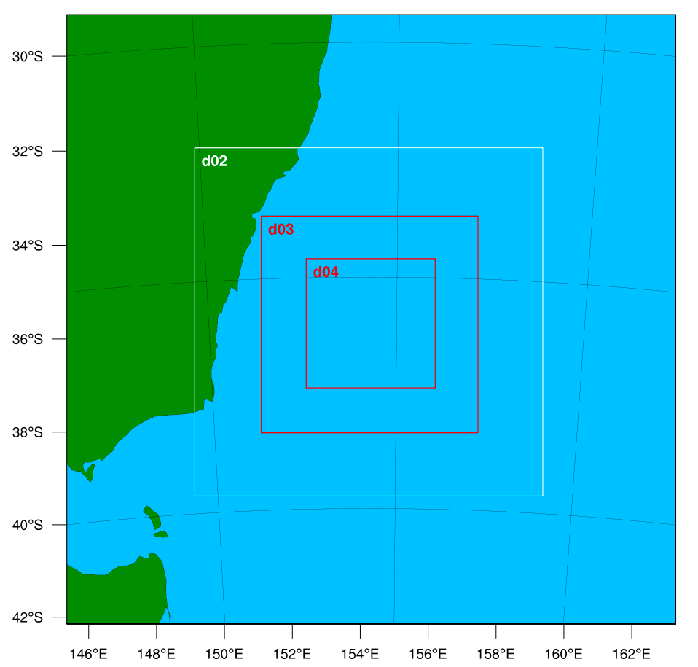
* Ship location at time of gust front: 154.3239 , -35.9070
* What is the max observed wind speed, and how is it defined?
  + Underway anemometer wind speed (available every 5 seconds): 30.3 m/s
  + Underway “wind gust” (also available every 5 seconds, but metadata says “max gust in 5 seconds”): 32.3 m/s
  + Data through AODN/IMOS (every one minute): 26.8 m/s
* WRF SSTs (from ERA5)  
  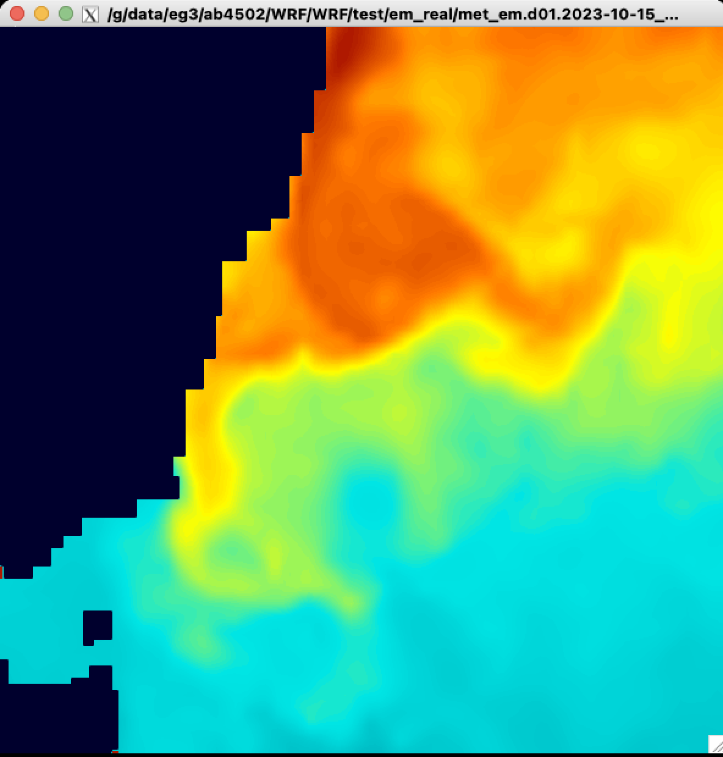  
    
  RAMSSA SSTs  
  